Economic Questions
Name
Institution

Economic Questions
Question 6
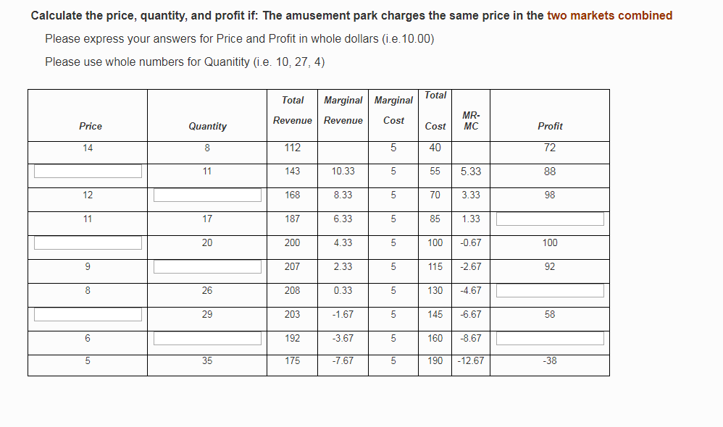
Price(p) | Quantity(q) | TR (p*q) | TC | PROFIT  (TR-TC)
14.00 | 8 | 112 | 40 | 72.00
13.00 (143÷11) | 11 | 143 | 55 | 88.00
12.00 | 14 (168÷12) | 168 | 70 | 98.00
11.00 | 17 | 187 | 85 | 102.00 (187-85)
10.00 (200÷20) | 20 | 200 | 100 | 100.00
9.00 | 23 (207÷9) | 207 | 115 | 92.00
8.00 | 26 | 208 | 130 | 78.00 (208-130)
7.00 (203÷29) | 29 | 203 | 145 | 58.00
6.00 | 32 (192÷6) | 192 | 160 | 32.00 (192-160)
5.00 | 35 | 175 | 190 | -15 (175-190)

Question 7
Profit Comparison for the Combined, Child, and Adult Markets
Prices | Profit (Without Discrimination) | Profit (Adult Market) | Profit (Child Market)
14.00 | 72.00 | 34.00 | 18.00
13.00 | 88.00 | 56.00 | 32.00
12.00 | 98.00 | 56.00 | 42.00
11.00 | 102.00 | 54.00 | 48.00
10.00 | 100.00 | 50.00 | 50.00
9.00 | 92.00 | 44.00 | 48.00
8.00 | 78.00 | 36.00 | 42.00
7.00 | 58.00 | 26.00 | 32.00
6.00 | 42.00 | 14.00 | 18.00
5.00 | -15.00 | 0.00 | 0.00
Total Profit | $715 | $370 | $330

The table above depicts the trend in profit maximization when the company adopts a price- discrimination strategy. Evidently, charging non-discriminative prices generate more profit than engaging discriminatory strategy. Charging similar prices for the services offered reduces the Total Cost that has positive effects toward the overall profit margin. Profit is calculated by deducting the total cost from the aggregate revenue that a business generates. Therefore, the company is able to save on cost when serving a combined market than providing amusement services that fit the adult and children market independently. For example, the firm generates a profit of $100 by charging 20 customers $10 at a cost of $100.
Working;
Total revenue = price * quantity
= 10*20
=$200
Profit= Total Revenue – Total Cost
=200-100
=$.100.00
Consequently, using price-discrimination to charge the child and adult portfolios generate adverse outcomes because of minimal profit yield. The company generates $370 and $330 profit for the Adult and Child Market portfolios respectively. The price-discrimination strategy depends on critical conditions to yield positive outcomes. First, market should be divided into actionable sub-categories that generate adequate revenue. Second, the different sub-markets should have varied price elasticity to facilitate the business achieve synergy. The two market portfolios exhibit different price elasticity because further increment of the prices charges for the Child market beyond $10 significantly reduces the profitability. At price $10.00 the company generate similar profit $50.00. The Adult Market exhibits an inelastic demand because the rise in prices to $11 increases the profit margin to $54.00.
Therefore, the company should charge similar prices for the Adult and Child Market portfolios because it generates an overall profit of $715. On the other hand, price discrimination yields an overall profit of $700 from the Adult and Child Market segments.
Question 8 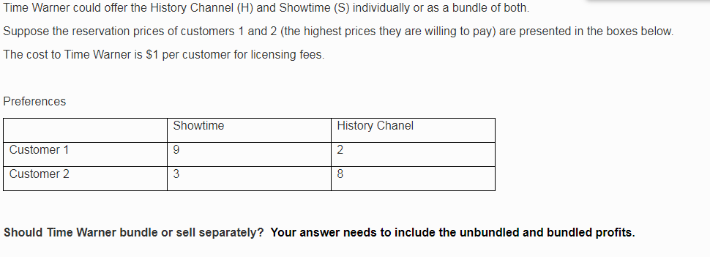
Profit = Selling Price- Cost
Aggregate profit for the Showtime= S.P_{showtime} – Cost_{licensing}
= (9-1) + (3-1)
= $10.00
Aggregate profit for the History Time = S.P_{History} – Cost_{licensing}
= (2-1) + (8-1)
= $9.00
Therefore, the overall unbundled profit from the sales of Showtime and History Channels is the sum of the two profit margins
Unbundled profit= Showtime_{profit} + History_{profit}
$10 + $9
=$19.00
Conversely, providing bundled Showtime-History will yield profit margin
Profit_{bundled} = S.P (Showtime and History) – cost of licensing
= (12+10) – 1
=$21.00
Recommendation:
The company should opt to provide bundled channel to capitalize on higher profit margin than charging individual services among the consumers. For example, selling Showtime-History bundled services generate a profit of $21.00 because it saves on the licensing fee, which is cost parameter that influences the level of profit margin.
Question 9
Using the new pricing option, the profit margins for the company is the difference between the selling price and the cost of licensing fees.
Showtime profit= S.P₁ – Cost_{licensing}
= 9 - 1
=$8.00-----------------,i,
History profit = S.P1 – Cost_{licensing}
= 8 – 1
=$7.00-------------------,ii,
Cumulative profit for selling individual Showtime and History packages
Overall Profit = Showtime profit + History Profit
= 8 + 7
=$15.00
On the other hand, using a mixed bundling service, the company generates fewer profit margins
Profit = S.P1- Cost_{licensing}
=13 – 1
Mixed bundling profit = $12.00
Recommendation:
The company should sell individual channels because it yields significant profit ($15) than using mixed bundling services. An increase in the price yields higher revenue, which allows the company to sell channels at maximum rates. However, the high revenue elicits a rise in operation cost because the company pays the licensing fee for each channel. Therefore, the company has to ensure total revenue surpasses the total cost incurred to avail the two channels independently to the market.

